Akshay Kumar Reddy Pagidiyala
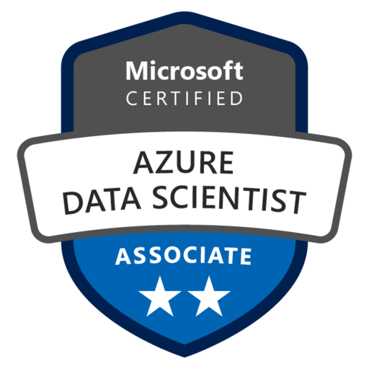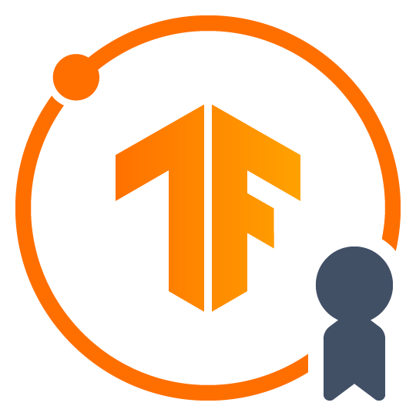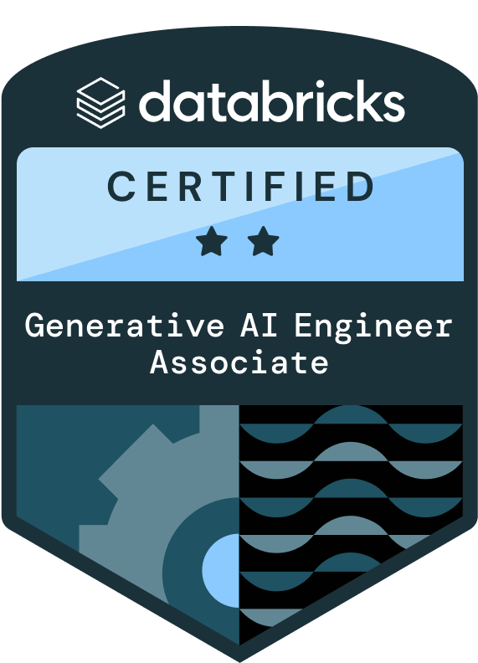
Data Scientist – GenAI Engineer
Phone: +1(815)-242-7512
Mail: akshaykumarreddypagidiyala@gmail.com
LinkedIn: www.linkedin.com/in/akshay-reddi/

PROFESSIONAL SUMMARY

- Over 11+ years of experience in delivering enterprise-scale Data Science, Machine Learning (ML), Artificial Intelligence (AI), Generative AI (GenAI), and advanced analytics solutions across industries such as finance, healthcare, retail, and telecom.
- Expertise in transforming raw data into actionable insights and measurable business outcomes by combining statistical modeling, machine learning, and business acumen.
- Designed and deployed Generative AI applications using GPT-4, Whisper, LangChain, and Hugging Face Transformers for intelligent chatbots, workflow automation, and document analysis.
- Fine-tuned domain-specific large language models (LLMs) such as BERT and GPT for summarization, classification, entity extraction, sentiment analysis, and risk detection, reducing manual review time and improving decision support.
- Skilled in supervised learning methods including regression, decision trees, random forests, gradient boosting, SVMs, and ensembles for predictive analytics, customer segmentation, and optimization tasks.
- Applied unsupervised learning techniques such as clustering (K-Means, DBSCAN, hierarchical) for anomaly detection, segmentation, and behavioral pattern discovery.
- Experienced in computer vision and deep learning, applying CNN-based architectures (ResNet, VGG16, MobileNet) and OpenCV for image classification, detection, and advanced vision tasks.
- Strong foundation in probability, Bayesian inference, causal analysis, and experimental design, including A/B testing and hypothesis-driven statistical modeling.
- Built advanced forecasting models using ARIMA, Prophet, and LSTMs to predict demand, sales, and operational trends, directly supporting business planning and resource optimization.
- Developed distributed data engineering pipelines with PySpark, Spark, Hadoop, and Scala across AWS, Azure, and GCP cloud platforms for scalable data processing.
- Built and maintained real-time data streaming solutions using Kafka, Spark Streaming, and NiFi, enabling event-driven analytics and live decision-making.
- Applied MLOps best practices with MLflow, Kubeflow, and TensorFlow Serving for model lifecycle management, reproducibility, and automated retraining.
- Operationalized ML workflows on AWS SageMaker, Azure ML, and GCP AI Platform, deploying production-ready solutions using Docker and Kubernetes for scalable, cloud-native AI systems.
- Integrated agentic AI workflows with observability systems to diagnose production issues and recommend remediation steps.
- Delivered interactive dashboards and advanced data visualizations using Tableau, Power BI, Matplotlib, and Seaborn, simplifying insights for stakeholders and enabling executive decision-making.
- Partnered with business leaders and product teams to define strategy, technical requirements, and measurable outcomes, ensuring alignment between AI solutions and organizational goals.
- Mentored and coached junior data scientists and engineers, fostering skill development, knowledge sharing, and adoption of best practices in AI/ML workflows.
- Experienced in delivering projects in Agile/Scrum environments, ensuring high-quality outcomes within time and budget while maintaining collaboration across cross-functional teams.
- Implemented secure function-calling and policy-enforced tool execution patterns aligned with Model Context Protocol (MCP) concepts.
- Applied explainability and interpretability methods such as SHAP, LIME, and attention visualization to ensure transparency, trust, and regulatory compliance of AI models.
- Ensured security, compliance, and ethical AI practices by applying governance frameworks, encryption, and privacy-preserving techniques to protect sensitive data.
- Implemented deterministic fallbacks and validation layers to prevent unsafe LLM actions in production.
- Experienced in integrating AI solutions into business domains such as risk management, customer intelligence, operational optimization, and regulatory compliance.
- Actively engaged in continuous learning by exploring the latest AI/ML research, attending conferences, and applying emerging technologies to enterprise use cases.
- Strong communication skills with a history of presenting AI-driven insights and recommendations to executives, influencing strategy, and supporting data-driven decision-making.
- Hands-on experience with Azure Machine Learning Service (Azure ML) for building, training, deploying, and monitoring scalable ML models in enterprise environments.
- Developed end-to-end ML pipelines on Azure ML using pipelines, datasets, and compute clusters to automate retraining and CI/CD integration with Azure DevOps.
- Leveraged Azure Synapse Analytics for large-scale data warehousing, ETL, and integration with Power BI to enable real-time advanced analytics and reporting. Built asynchronous REST APIs using FastAPI with AsyncIO patterns, Pydantic validation, and JWT-based authentication to serve LLM-powered agents in production.
- Implemented Azure Cognitive Services (Vision, Text Analytics, Translator, and Speech) to enrich applications with out-of-the-box AI capabilities.
- Built and optimized big data pipelines using Azure Data Factory (ADF), Data Lake Storage, and Databricks for ingestion, transformation, and model training on large-scale datasets.
- Deployed containerized AI/ML solutions via Azure Kubernetes Service (AKS) for elastic scalability, high availability, and enterprise-grade security.
- Applied Azure Monitor and Application Insights for tracking model performance, logging, and anomaly detection in production ML workflows.
- Utilized Azure Responsible AI dashboard for bias detection, fairness evaluation, and explainability to ensure ethical deployment of models in regulated industries.
- Designed hybrid and multi-cloud AI architectures combining Azure with AWS/GCP for resilience, cost optimization, and regulatory compliance.

EDUCATION:

- Master of Science in Computer Science, Illinois Institute of Technology, Chicago, Illinois, USA, Dec 2013
- Bachelor of Technology in Electronics and Communication Engineering, Jawaharlal Nehru Technological university, Hyderabad, India, May 2011

CERTIFICATIONS:

- Databricks Certified Generative AI Engineer
- TensorFlow Developer
- Microsoft Certified Azure Data Scientist Associate

TECHNICAL SKILLS:
Programming Python, Java, JavaScript, R, C++, SQL, HTML, CSS, Scala, ReactJS, Next.js, Angular, jQuery, REST APIs, Postman, Swagger,Node.js, FastAPI
ML Algorithms Scikit-learn, XGBoost, LightGBM, Random Forest, Gradient Boosting, SVM, KNN, Naive Bayes, Logistic Regression, Linear Regression, Decision Trees, Classification Algorithms, Clustering (K-Means, Hierarchical), Dimensionality Reduction (PCA, t-SNE), Feature Engineering, Hyperparameter Tuning, Cross-Validation, Model Evaluation, Ensemble Methods, SHAP, LIME, Recommendation Systems.
Deep Learning & Neural Networks TensorFlow, PyTorch, Keras, CNN, RNN, LSTM, Bi-LSTM, GRU, Transfer Learning (VGG, ResNet), Attention Mechanism, Object Detection (YOLO, Faster-R-CNN), Image Segmentation (U-Net, Mask R-CNN), OCR, Autoencoders, GANs, VAEs, Optimization Algorithms (Adam, SGD), Regularization (Dropout, Batch Normalization)
GenAI & LLMs LangChain, LangSmith, GPT, BERT, T5, RAG (Retrieval-Augmented Generation), Prompt Engineering, Fine-tuning (LoRA, QLoRA), Hugging Face, Ollama, Agentic AI, Diffusion Models, Text-to-Image Generation, Chatbots, AI Search Engines, Vector Databases (FAISS, Pinecone, Chroma), Zero-Shot Learning
MLOps & Model Operations MLflow, Airflow, Kubeflow, Docker, Kubernetes, Model Deployment & Monitoring, CI/CD for ML, Experiment Tracking, Weights & Biases, Feature Stores (Feast), TruLens, PromptLayer, vLLM, TGI, DVC, Prometheus, Grafana
Big Data & Distributed Computing Hadoop, HDFS, YARN, Apache Spark, PySpark, Spark SQL, Spark MLlib, Hive, Impala, Pig, Sqoop, Kafka, Kinesis, Scala, MapReduce, PyArrow, Distributed Data Processing, Performance Tuning
Database Systems & Storage MySQL, PostgreSQL, MongoDB, SQLite, Microsoft SQL Server, Redshift, DynamoDB, Snowflake,Teradata, SQLAlchemy, Neo4j (Graph DB), RDS, Vector Databases (FAISS, Pinecone)
Cloud Platforms
      - AWS EC2, Lambda, SageMaker, Bedrock, EMR, S3, Glue, Kinesis, QuickSight, API Gateway, Athena, Rekognition, DynamoDB, CloudFormation, CloudWatch, IAM
      - Azure Data Factory, Databricks, Synapse Analytics, Blob & Data Lake Storage, Event Hubs, Logic Apps, Functions, Stream Analytics, Monitoring
      - GCP Vertex AI, AI Platform, BigQuery
Development Tools & Environments Git, GitHub, GitLab, Docker, VS Code, Jupyter Notebook, Google Colab, CUDA Toolkit, Linux/Unix, Bash Scripting, Conda.

PROFESSIONAL EXPERIENCE:
JP Morgan Chase – New York, NY July 2022 - Present
Data Scientist – GenAI Engineer
Roles & Responsibilities:

- Led a cross-functional team of AI/ML engineers to develop a large-scale contract management platform using GPT-4, LangChain, and Azure ML, automating clause extraction and review and reducing contract processing time by over 60%.
- Designed and implemented agentic AI–based contract review agents using GPT-4 and LangChain to autonomously execute multi-step workflows including clause extraction, risk comparison, redlining, and summary generation.
- Built agentic AI systems with dynamic tool-calling capabilities integrating Azure Cognitive Search, FAISS, Pinecone, and document parsers for intelligent retrieval across large-scale contract repositories.
- Implemented agentic AI memory and context management to maintain case-specific conversation history, improving continuity and accuracy in long-running legal document review sessions.
- Built moderate agentic AI workflows using LangChain Agents enabling LLM planning and multi-step execution with tool-calling to search engines, vector databases, and document parsers.
- Developed intelligent chatbots integrated with Azure Cognitive Services (Language, Search, Speech) to provide real-time responses to compliance and legal queries.
- Built NLP pipelines for clause extraction, entity recognition, sentiment analysis, and document classification using Transformers, spaCy, and NLTK.
- Implemented Transformer-based models including BERT and GPT using TensorFlow, PyTorch, and Keras for text summarization, classification, and legal document interpretation.
- Fine-tuned large language models using few-shot learning, transfer learning, and prompt engineering to improve accuracy and contextual understanding of legal documents.
- Developed RLHF (Reinforcement Learning from Human Feedback) loops to refine LLM outputs based on domain-specific legal feedback and improve AI reliability.
- Integrated semantic search and keyword extraction using FAISS and Pinecone for Retrieval-Augmented Generation (RAG) enabling fast search across thousands of contracts.
- Applied explainability frameworks such as SHAP and LIME along with Azure Responsible AI Dashboard to interpret model predictions and ensure transparency.
- Utilized machine learning algorithms including XGBoost, LightGBM, and Scikit-learn for contract risk prediction, anomaly detection, and advanced analytics using GAI models.
- Automated LLM retraining and model lifecycle pipelines using MLflow and Azure DevOps CI/CD ensuring continuous model improvement and reproducibility.
- Designed and deployed FastAPI-based asynchronous REST services using AsyncIO and Pydantic schemas for LLM orchestration and agent execution.
- Built high-performance FastAPI microservices for LLM inference and RAG orchestration with authentication, retry logic, and scalable async architecture.
- Integrated Azure OpenAI and RAG pipelines into production-grade API services enabling enterprise-grade AI capabilities.
- Designed stateless and stateful AI microservices optimized for serverless architectures and distributed inference workloads.
- Containerized AI services using Docker and deployed scalable inference APIs on Kubernetes (AKS) using TensorFlow Serving and Kubeflow.
- Deployed containerized AI microservices on AWS ECS Fargate with Amazon ECR integration for scalable cloud-native deployments.
- Designed RESTful APIs behind Amazon API Gateway with IAM-based authentication and secure service communication.
- Integrated Amazon Bedrock foundation models for enterprise-grade LLM inference and AI-powered automation.
- Implemented DynamoDB and Aurora databases for persistent storage and session management of stateful AI agents.
- Provisioned and managed AWS infrastructure using Terraform and CloudFormation including ECS, Lambda, API Gateway, IAM roles, Secrets Manager, and VPC resources.
- Designed and managed ETL workflows using Apache Airflow, NiFi, and StreamSets to process large-scale contract datasets stored in Hadoop, Hive, and Spark environments.
- Processed and transformed large datasets from HDFS, AWS S3, and Azure Blob using Spark DataFrames and RDDs for distributed data processing.
- Performed data validation, preprocessing, and exploratory analysis using Pandas, NumPy, SciPy, Matplotlib, and Seaborn.
- Integrated AI results into enterprise analytics platforms including Azure Synapse Analytics and dashboards built using Power BI and Tableau.
- Managed hybrid databases including Cassandra, MongoDB, OrientDB, PostgreSQL, MySQL, and SQL Server supporting diverse workloads.
- Leveraged multi-cloud infrastructure across AWS (EC2, S3, EMR) and GCP (Dataproc, AI Platform) for distributed model training and benchmarking.
- Monitored machine learning pipelines and production systems using Splunk, Azure Monitor, Control-M, and Cloudera Navigator with automated alerts.
- Maintained compliance and enterprise data security through encryption, access controls, and Responsible AI governance frameworks.
- Conducted A/B testing and performance evaluation of AI models using interpretability techniques including attention heatmaps and explainability metrics.
- Built multilingual conversational AI assistants using Whisper speech-to-text and LangChain conversational workflows.
- Mentored junior engineers and promoted MLOps best practices with documentation through Confluence and SharePoint.
- Managed source control and CI/CD pipelines using Git, GitHub, Bitbucket, and Bamboo ensuring reliable deployment automation.
- Participated in Agile development processes using JIRA for sprint planning, backlog grooming, and cross-functional collaboration.
- Translated complex AI and machine learning concepts into business-friendly insights for executives and non-technical stakeholders.
- Optimized compute utilization across Azure Kubernetes Service and Azure ML clusters reducing training costs by approximately 30%.
Environment: TensorFlow, PyTorch, Keras, Scikit-learn, XGBoost, LightGBM, Transformers, spaCy, NLTK, LangChain, OpenAI
GPT-4, Whisper, MLflow, Kubeflow, TensorFlow Serving, SHAP, LIME, FAISS, Pinecone, Azure Machine Learning, Azure Synapse Analytics, Azure Responsible AI Dashboard, Python, R, SQL, Scala, Pandas, NumPy, SciPy, Matplotlib, Seaborn, Apache Spark, PySpark, Spark SQL, Spark MLlib, Hadoop, Hive, Impala, MapReduce, Apache Airflow, NiFi, StreamSets, Flume, Oozie, Zookeeper, Beeline, Control-M, ICEDQ, Cloudera Navigator, Azure (Machine Learning, Synapse, DevOps, Monitor, AKS), AWS (S3, EC2, EMR), GCP (Dataproc, AI Platform), Docker, Kubernetes, Git, GitHub, Bitbucket, Bamboo, JIRA, PostgreSQL, MySQL, SQL Server, Cassandra, MongoDB, OrientDB, HDFS, Azure Blob Storage, Power BI, Tableau, Confluence, SharePoint, Splunk.

Walmart - Sunnyvale, CA Mar 2019 – Jun 2022
AI Engineer
Roles & Responsibilities:

- Designed and deployed end-to-end Azure-based data pipelines to extract, clean, integrate, and validate complex datasets from diverse organizational sources, loading them into dimensional models for downstream analytics.
- Designed and deployed end-to-end Azure-based data pipelines using Azure Data Factory, Azure Databricks, and Azure HDInsight, orchestrating extraction, transformation, and loading (ETL) of complex datasets into dimensional models. Improved accessibility and reduced data latency for analytics teams.
- Performed exploratory data analysis (EDA) with PySpark, SparkSQL, Pandas, and Matplotlib on Azure Databricks to uncover patterns, detect anomalies, and engineer features. Simplified insights for stakeholders through clear data storytelling.
- Optimized high-dimensional datasets in Azure Data Lake Storage (ADLS) by applying PCA, correlation analysis, and feature selection. Enhanced ML model efficiency and reduced cloud storage costs.
- Built scalable AI algorithms for predictive maintenance, anomaly detection, and optimization on Azure Machine Learning using BFS and DFS search techniques. Improved system reliability and proactive issue detection.
- Modeled decision processes through Markov Decision Processes (MDPs) and implemented reinforcement learning algorithms (Qlearning, policy gradient methods) in Azure ML to optimize operational and maintenance policies.
- Developed predictive models—Logistic Regression, Decision Trees, Random Forests, Gradient Boosting, SVM, XGBoost, and LightGBM—using Scikit-learn and MLlib. Achieved high-accuracy classification and regression for business forecasting.
- Applied unsupervised learning (K-Means, Hierarchical Clustering, DBSCAN) on Azure Databricks to segment customers and operational behaviors, improving targeted decision-making for business teams.
- Built NLP pipelines with NLTK, spaCy, and TextBlob for tokenization, sentiment analysis, and text pattern extraction; implemented TF-IDF, embeddings, and LDA topic modeling using Azure Cognitive Services to extract insights from unstructured text.
- Designed and trained deep learning models using TensorFlow, Keras, and PyTorch within Azure ML for predictive analytics and temporal data processing. Deployed CNNs and RNNs on Azure GPU clusters for real-time IoT analysis.
- Deployed production-grade AI services via Azure Kubernetes Service (AKS) and automated workflows using Python, Shell scripting, and Azure SDKs. Built reproducible CI/CD pipelines with Azure DevOps and Git for efficient model delivery.
- Engineered large-scale ETL pipelines with Hadoop, Hive, HDFS, Sqoop, and Oozie on Azure HDInsight, and implemented realtime streaming with Kafka, Spark Streaming, HBase, and Azure Event Hubs for instant analytics.
- Integrated and managed diverse databases including Azure SQL Database, Teradata, Oracle, MongoDB, and Azure Cosmos DB, using PySpark connectors to link with external APIs and on-prem systems.
- Built Power BI dashboards integrated with Azure Synapse Analytics and ML outputs for unified executive reporting. Applied SHAP and LIME to explain model results, fostering trust among business users.
- Implemented Azure Purview for enterprise-wide data cataloging, lineage tracking, and governance. Ensured compliance, traceability, and trust in AI-driven insights.
- Used Azure Monitor, Log Analytics, and Application Insights for proactive monitoring of pipelines, models, and system health. Created alerting systems for anomalies and SLA breaches.
- Applied cost optimization strategies using Azure Cost Management and Advisor to fine-tune Databricks clusters, AKS workloads, and compute-intensive pipelines, saving up to 25% in cloud spend.
- Designed secure data access frameworks with Azure Role-Based Access Control (RBAC), Managed Identities, and Key Vault, safeguarding sensitive financial and IoT data.
- Collaborated with cross-functional teams including business analysts, domain experts, and engineers to align ML outcomes with operational goals. Facilitated workshops to explain AI insights in simple, actionable terms.
- Promoted Agile best practices across sprints, using JIRA and Azure DevOps for backlog tracking and delivery planning. Conducted knowledge-sharing sessions to mentor junior engineers and drive team maturity.
- Architected hybrid Azure–on-premises solutions combining Azure ML, Azure Storage, and edge computing for low-latency inference in IoT and regulated environments. Balanced compliance needs with performance goals.
Environment: Azure Databricks, Azure Machine Learning, Azure Data Factory, Azure Data Lake Storage (ADLS), Azure Blob
Storage, Azure HDInsight, Azure Kubernetes Service (AKS), Azure Event Hubs, Azure SQL Database, Azure Cosmos DB, Hadoop, PySpark, SparkSQL, Spark Streaming, Hive, HDFS, Sqoop, Oozie, Kafka, HBase, MLlib, Scikit-learn, TensorFlow, PyTorch, Keras, XGBoost, LightGBM, Pandas, NumPy, Matplotlib, Seaborn, Plotly, NLTK, spaCy, TextBlob, SHAP, LIME, SQL, Teradata, Oracle, MongoDB, Shell Scripting, UNIX, Git, Azure DevOps, Agile, HP ALM/Quality Center, WinSQL.

Aetna– Hartford, CT Dec 2016 – Feb 2019
ML Engineer
Roles & Responsibilities:

- Led healthcare claims data analysis using large-scale datasets to support cost optimization, provider performance tracking, and risk adjustment modeling aligned with HIPAA compliance.
- Worked with FACETS claims system for extracting member, provider, and claims data for analytics and reporting.
- Used Advanced Excel (Pivot Tables, VLOOKUP/XLOOKUP, Power Query, VBA Macros) for healthcare claims reconciliation, KPI tracking, and executive reporting.
- Defined KPIs and reporting standards across healthcare operations.
- Acted as primary liaison between business stakeholders and analytics teams.
- Processed and integrated enterprise-scale data from SQL Server, Oracle, Teradata, Hadoop (HDFS, MapReduce, Pig), Spark, and Hive; ensured compliance with GDPR/CCPA standards and maintained audit logs for all data activities.
- Applied distributed computing strategies on EMR clusters to parallelize data preparation and model evaluation, improving compute utilization and lowering overall runtime.
- Optimized feature pipelines and preprocessing workflows using AWS Glue and Spark, reducing end-to-end training-pipeline execution time by 30 percent and improving consistency across retraining cycles.
- Developed and maintained data lineage documentation using ER Studio and AWS Data Catalog to improve traceability and reproducibility of ML experiments.
- Designed and deployed classification and forecasting models including Logistic Regression, SVM, Random Forest, Naive Bayes, and K-Means on Amazon SageMaker, improving claims and KPI forecasting accuracy by more than 15 percent.
- Applied regression and supervised ML to predict churn, renewals, and claims volume, processing large-scale datasets through AWS Glue-based ETL pipelines and PySpark on EMR for scalable data preparation.
- Performed feature selection, scaling, and PCA/correlation analysis with Pandas, NumPy, and Scikit-learn to enhance efficiency, reduce overfitting, and improve model explainability.
- Applied cross-validation, hyperparameter tuning, and ensemble averaging on high-dimensional S3 datasets, ensuring robust, generalizable performance across multiple business segments.
- Developed customer-segmentation pipelines using K-Means, Hierarchical Clustering, and DBSCAN orchestrated with Apache Airflow on AWS, driving targeted marketing and operational resource optimization.
- Engineered deep learning architectures such as CNNs, RNNs, and MLPs with TensorFlow and PyTorch on EC2 GPU instances for claims prediction, renewals, and risk assessment. Implemented dropout and L1/L2 regularization to stabilize learning.
- Built NLP pipelines with NLTK, spaCy, and Gensim for tokenization, named-entity recognition, sentiment, and topic modeling; automated near-real-time inference using AWS Lambda with TF-IDF and Word2Vec embeddings.
- Designed AI-driven optimization frameworks for predictive maintenance and anomaly detection, integrating BFS/DFS search with statistical learning. Presented outcomes through Power BI dashboards for operational teams.
- Deployed GPU-accelerated inference pipelines through TensorFlow Serving and TorchServe, scaling workloads via containerized microservices managed in Kubernetes (EKS) for high availability.
- Monitored production ML models using MLflow and custom Python scripts to detect model drift and automatically trigger retraining and endpoint refresh on SageMaker.
- Implemented model versioning and feature-store integration using MLflow, DVC, and Feast; built CI/CD pipelines with Jenkins and GitHub Actions for automated testing and deployment across environments.
- Partnered with DevOps teams to containerize ML services using Docker and deploy them across hybrid AWS and on-prem environments, ensuring reproducibility and secure scaling for mission-critical applications.
- Conducted A/B testing and model-performance benchmarking to validate ML outcomes, translating statistical metrics into businessfriendly KPIs for executive review.
- Created clear, interpretable data visualizations with Matplotlib, Seaborn, and Plotly, combined with Power BI, BusinessObjects, and Web Intelligence to deliver interactive business insights and reduce dashboard load times by 20 percent.
- Collaborated with Principal Data Scientists, data engineers, and business stakeholders to transform ambiguous problems into measurable ML solutions; provided presentations to leadership outlining ROI and impact.
- Mentored junior engineers and analysts on ML best practices, Python coding standards, and AWS deployment workflows, fostering a collaborative learning environment.
- Promoted Responsible AI principles by integrating model-explainability libraries such as SHAP and LIME within production pipelines, increasing transparency and regulatory compliance.
Environment: AWS (S3, SageMaker, EMR, Lambda, EC2, Redshift, Glue, Airflow, EKS), FACETS, Python (Pandas, NumPy, SciPy, Scikit-learn, TensorFlow, Keras, PyTorch, NLTK, spaCy, Gensim, MLflow, DVC, Feast), PySpark, Spark SQL, Hadoop (HDFS, MapReduce, Pig), Hive, SQL, Oracle, SQL Server, Teradata, Kubernetes, Docker, TensorFlow Serving, TorchServe, Power BI, BusinessObjects, Web Intelligence, Advanced Excel (Pivot Tables, VLOOKUP/XLOOKUP, Power Query, VBA Macros), ER Studio, AWS Data Catalog, Matplotlib, Seaborn, Plotly, Jenkins, GitHub Actions, XML, JSON.

Coca – Cola- Atlanta, GA Jan 2014 – Nov 2016
Data Analyst
Roles & Responsibilities:

- Conducted end-to-end data analysis, migration, and preparation using Azure SQL Database and on-premises SQL Server Integration Services (SSIS), consolidating structured and semi-structured datasets to support customer segmentation, marketing optimization, and reporting automation.
- Developed predictive and statistical models in Python (NumPy, SciPy, Scikit-learn) and R within Azure Notebooks and local Jupyter environments to perform forecasting, regression, and trend analysis, improving reporting accuracy and proactive decisionmaking.
- Designed, optimized, and validated complex SQL queries with joins, subqueries, and aggregations across Azure SQL Database and Oracle SQL Developer to reconcile multi-source data and ensure integrity in enterprise reporting.
- Built and maintained ETL pipelines using SSIS, Azure Data Factory, and Python scripts to extract, transform, and load data from flat files, Oracle, and on-prem systems into Azure SQL Database, ensuring reliable and consistent data ingestion.
- Designed and optimized OLAP and OLTP data models using ERwin and Azure SQL Server Analysis Services (SSAS), developing star and snowflake schema data marts that supported Power BI and Tableau dashboards for real-time business intelligence.
- Leveraged Python libraries including Pandas and NumPy for data cleaning, transformation, and feature engineering, and applied NLTK-based text processing for sentiment analysis and keyword extraction to uncover business insights.
- Created automated validation workflows using Python, VBA, and SQL stored procedures to cross-check multivariate datasets, reducing manual data quality checks and improving accuracy by 15%.
- Used Hadoop (MapReduce, Hive) integrated with Azure HDInsight to process and aggregate high-volume datasets, feeding curated summaries into Azure SQL Database for analytical consumption and executive reporting.
- Designed Power BI and Tableau dashboards integrated with Azure SQL Database to visualize key KPIs, sales trends, and operational metrics, improving business visibility and enabling self-service analytics across teams.
- Collaborated with marketing, finance, and operations teams to translate business requirements into analytical SQL workflows and visual models, aligning KPIs with organizational goals and driving strategic improvements in forecasting and performance tracking.
- Partnered with data governance teams to implement secure data access, version control, and lineage tracking using Azure Active Directory, Git, and TortoiseSVN, ensuring compliance and controlled collaboration among analytics teams.
- Conducted root-cause analysis for data discrepancies and implemented corrective SQL logic to standardize business definitions and improve reliability in enterprise reports distributed to senior leadership.
- Automated data refresh cycles through Azure Data Factory triggers and Power BI gateway scheduling, ensuring that dashboards and KPIs were continuously updated for timely decision-making.
- Mentored junior analysts on SQL performance tuning, ETL best practices, and Power BI report development; promoted knowledge sharing and consistency across analytics documentation and processes.
- Collaborated with project managers and cross-functional stakeholders to align analytics deliverables with business timelines, improving transparency, stakeholder engagement, and overall project efficiency.
Environment: Azure SQL Database, Azure HDInsight, SQL Server (SSMS, SSIS, SSAS), Oracle SQL Developer, ERwin Data
Modeler, Tableau 8.x, Microsoft Excel (VBA, Macros, Pivot Tables), Python (Pandas, NumPy, SciPy, scikit-learn, NLTK), R, Hadoop (MapReduce, Hive), Git, TortoiseSVN, Windows Server.

